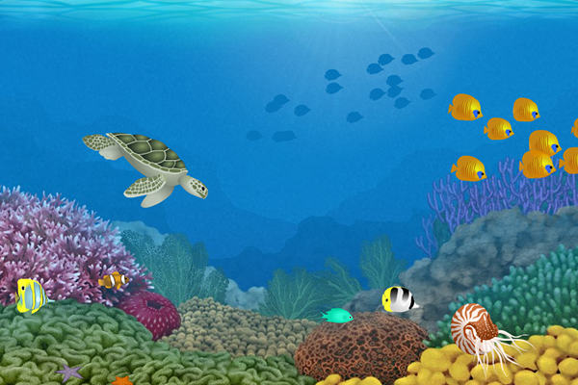

I can be lots of colours or only one.

I used to be a home but now I’m not.

You may hear the sea inside me.

**What am I?**

My shell is my skeleton,

I have claws.

I eat worms, molluscs and algae.

**What am I?**

I can be in the sea or in the sky.

People call me beautiful.

When I lose an arm, I can grow one back.

**What am I?**