Word of the Day
Monday 29th June 2020
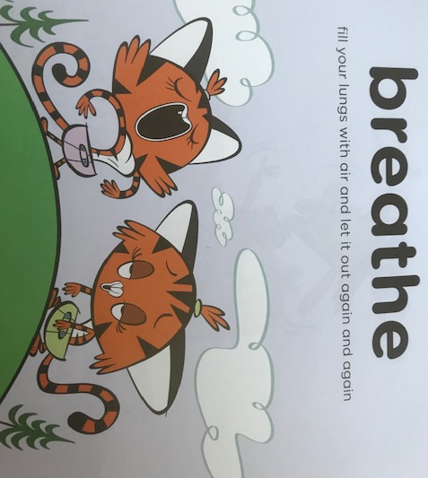

Definition:
Fill your lungs with air and let it out again and again. “She felt a bit worried so she breathed deeply to help calm herself down.”
Challenge:

When you feel a bit worried you can practise your slow, deep breathing. Can you breathe in for the count of 5 and breathe out for the count of 5? Once you get really good at slow, deep breathing you can breathe in for the count of 6!

