Word of the Day
Monday 22nd June 2020

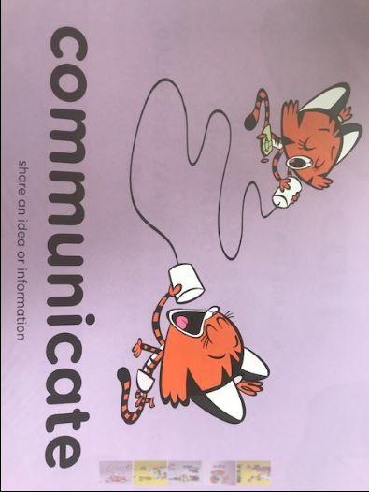
Definition:
Share an idea or information. “The teacher communicated to the children.”
Challenge:

Can you practise your good communication skills today? Try smiling, make eye contact and use a person’s name before you start speaking to them.

