1.6.20 All About Me Rainbow Challenge

- Draw a rainbow
- In each part of the rainbow, write an adjective to describe yourself
- Then, colour in the rainbow
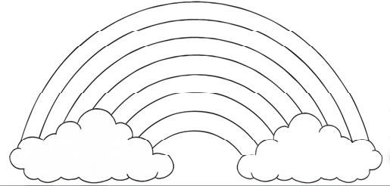

Please send any completed rainbows to the school that you wish to share.
Enjoy!

