Word of the Day
Friday 3rd July 2020
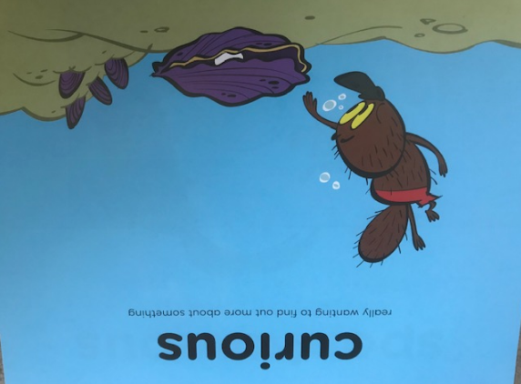

Definition:
Really wanting to find out more about something. “He was curious to see what was inside the fluted, purple shell.”

Challenge:

Curiosity is a one of the character strengths. Do you have it as a strength?
Can you use the word “curious” when you are talking about your learning today. Do you have any questions about your new class or teacher next year that you can ask an adult?

