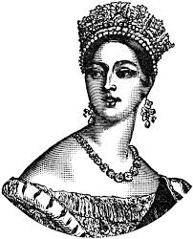
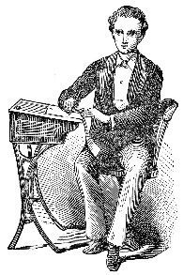
Year 1 Summer Term 2018
Blast from the past!
What was life like in Victorian times?

History  The children will begin the topic by learning about Queen Elizabeth, then moving back in time to the reign of Queen Victoria. They will learn what life was like for children during the Victorian period using texts, trips and artefacts. | Art  We will be exploring the work of Victorian artist William Morris and comparing to the modern print maker Orla Kiely. The children will use this as a basis to develop press printing work as well as using art packages on the computer. We will also be working on digital photography skills, learning how to take and then edit images.
Literacy
We will be using our reading skills to help us find out the answers to historical questions. We will use our non-fiction writing skills to present what we have found out. We will be focusing on the following skills:
- Checking our finished work and correcting mistakes, including spelling (Year 1 exception words)
- Making sure our letters are formed correctly and are facing the right way.
- Understanding how apostrophes are used to represent omitted letters e.g. I’m (I am), can’t (cannot),
- Using prefixes (‘un-‘) and suffixes (‘-est’, ‘-er’, ‘-ing’, ‘-ed’ and plurals ‘-s/-es’) correctly in our writing

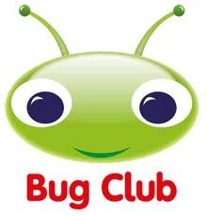
Phonics and ‘Bug Club’
‘Bug Club’ is a particularly useful online resource as it has a range of phonic based texts as well as games to play. You should find your child’s login details in their contact book and can find their books under ‘My Stuff’ once they have logged in. Don’t forget to look out for the ‘bugs’ hidden in the pictures; clicking on these will take you to question to check your child’s understanding of the text they have read.

Maths
We will be focusing on the following areas:
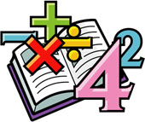
- Time –Telling the time on a clock to the hour and half past; using language to describe time and sequence events linked to or history work
- Multiplication and Division – using objects, pictures and arrays to help us multiply and divide
- Fractions – finding halves and quarters of shapes and amounts.
- Measure – using language linked to capacity, length/height and mass and recognising the value of coins and notes.

PSHCE & RRS  Our focus theme will be ‘Relationships’ and linking this to the Rights Respecting Schools program. | PE  The Chelsea coaching team will be teaching Athletic skills on a Thursday. These sessions will be outside so please ensure your child has suitable PE shoes and tracksuit bottoms/leggings in case of chilly weather.  Indoor Dance will on a Monday for Badgers, Tuesday for Foxes and Squirrels, and a Friday for Hedgehogs.  Library sessions:  Badgers-Thursday  Hedgehogs, Squirrels and Foxes – Friday
Music:
The children will continuing to develop their ocarina skills and will be learning ‘Yankee Doodle’.

RE:
We will be exploring the theme of ‘Belonging’; talking about the different groups we belong to.
Diary dates
24th April – Weald and Downland visit
9th May – Victorian dress up day
Please could the children come to school dressed as a rich or poor Victorian child. They will spend the day experiencing a “day in the life” with schooling, play and bread and butter making.

Homework
We suggest that you work little and often with your child to support the work they do in school. A 10 minute session every day is far more beneficial than a very long session once a week. Homework should include:
- Reading at least 4 times per week. Don’t forget you can also use the online ‘Bug Club’ texts.
- Regular revisiting of maths targets sent home
- Phonic homework
- Continue to support their learning of Year 1 spelling words. A list of Year 1 ‘Exception Words’ is available in the ‘Curriculum - English – Spelling’ section of the school website.
Thank you for your support. Please speak to your child’s class teacher if you need any further ideas on how to best support your child at home.

Reminders:
Please make sure all items and uniform and PE kit are named and that your child know where to check for their name to find their own belongings.
Please do not allow your child to bring toys, games or trading cards into school.
We are working towards renewing our “Healthy Schools” status and would appreciate all children having water bottles with water, not squash in please.
Please help your child to be more independent by coming into the classroom on their own and putting their resources in the correct places.
Many thanks
Mrs Davy and the Year 1 team

