Bug Club - A Guide for Parents

What is Bug Club?
Bug Club is a fantastic online resource for supporting your child with their phonics, reading, spelling and grammar at home. You can use the online texts for reading at home and record this in your child’s contact book. Lyndhurst Infant School provides all children with their own personal Bug Club account. The login details for this can be found in their reading contact book. Bug Club should work on most PCs and tablets. The login page includes a ‘Will it work on my computer?’ check that you can run.

How do we use Bug Club?
When you visit www.actvitvelearnprimary.co.uk you will see a login screen.
Your child should type in their username and password but don’t forget the ‘School code’ – g7sw.

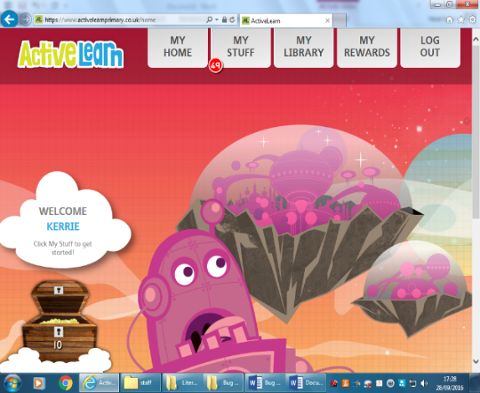

Once you have logged in, they click on the ‘My Stuff’ tab to
see the e-books available.

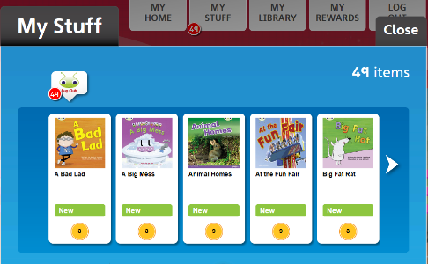

Then simply click on the book you would like to use with your child. This may open in a new window so make sure that you allow pop-ups for this website.

Bug Club books start with a guide to the sounds and ‘tricky’ words
featured in the book. It is a good idea to practice these with your
child before they start to read to you.

The controls appear at the bottom of the page:
- ‘Next’ and ‘Back’ arrows to turn the pages
- A magnifying glass to zoom in and make the text larger
- A red cross to close the book.
- The ‘Read to me button’ may be useful if your child is a reluctant reader. Try to encourage them to read a page, listen to a page and so on.

What do the quiz bugs do?
As you are reading, look out for the bugs that appear on some pages. Clicking these will take you to a question or other activity to check your child’s understanding of what they have read.

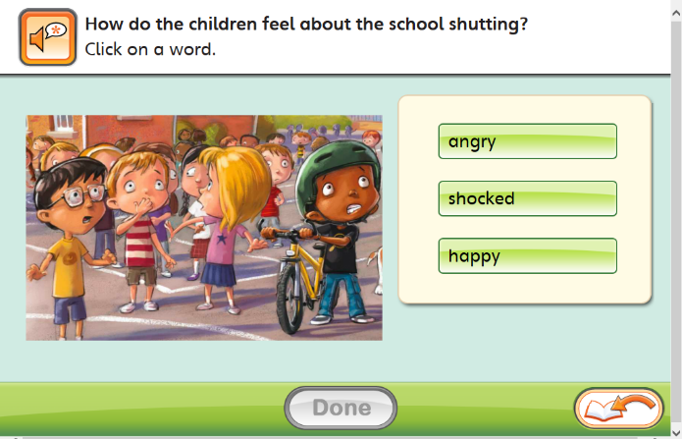

Answering these questions will also help your child earn treasure (Bug Club Reward Points) - we will come back to this later!

Click ‘Done’ to check your answer and the ‘Back to the Book’ symbol to carry on reading.

What do we do with our Bug Club points?
By completing books and answering bug questions, your child will earn Bug Club Rewards! Click on the ‘My Rewards’ tab, then visit either:
- The Pit Stop – Here you can spend points to create a vehicle and play a short racing game
- The Sticker Factory – Here you can spend your points to create an online sticker album
- The Tree House – Here you can spend points to design and create a tree house for your bug

Do children get a chance to use Bug Club at school?
Yes! We use Bug Club as part of our phonics and SPAG (spelling, punctuation and grammar teaching). We also use it for some guided and individual reading sessions.

We ask parents/carers to read with your child at least 4x per week and would encourage you to use Bug Club e-books with your child as part of this. It supports the new curriculum focus on phonic skills for reading, as well as developing comprehension and SPAG skills (spelling, punctuation and grammar). We have found that it can also be particularly useful for engaging reluctant readers.
We hope that you have found this guide useful. If you have any additional questions please ask your child’s class teacher.

Trouble shooting:

There is a problem with my child’s book allocations e.g. they seem to be the wrong level: Teachers keep a regular check on the books that have been read and the quizzes that have been completed and use this to update allocations. As with all technology however, things sometimes go wrong! Please speak to your child’s class teacher if you think there may be an issue with their book allocations.

Our login details do not work: As a first step, check that your child is not using capital letters, leaving spaces in their login name or forgetting to put in the school code. If problems continue please speak to your child’s class teacher and we can ask our ICT manager to investigate further.

