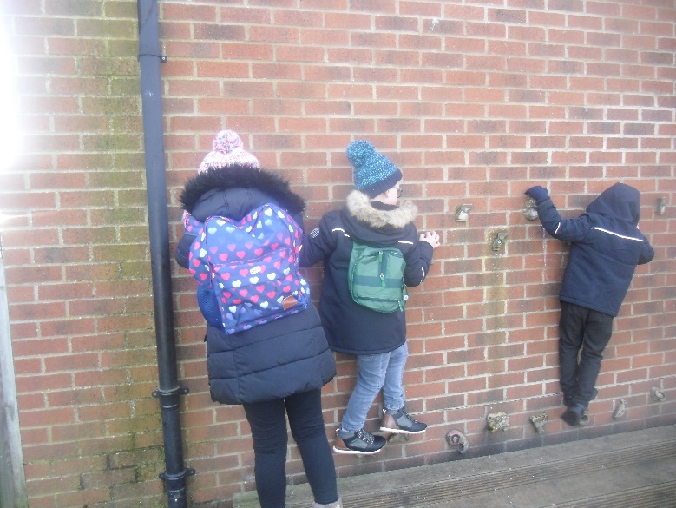
Our Polar Expedition
We all had fun…
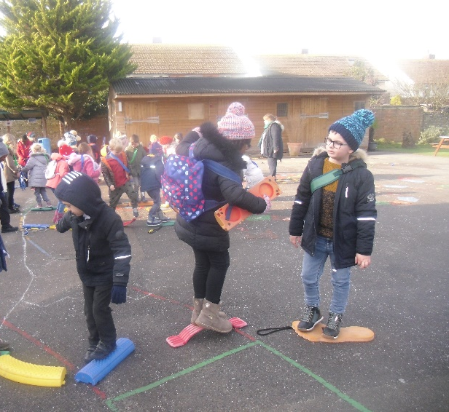

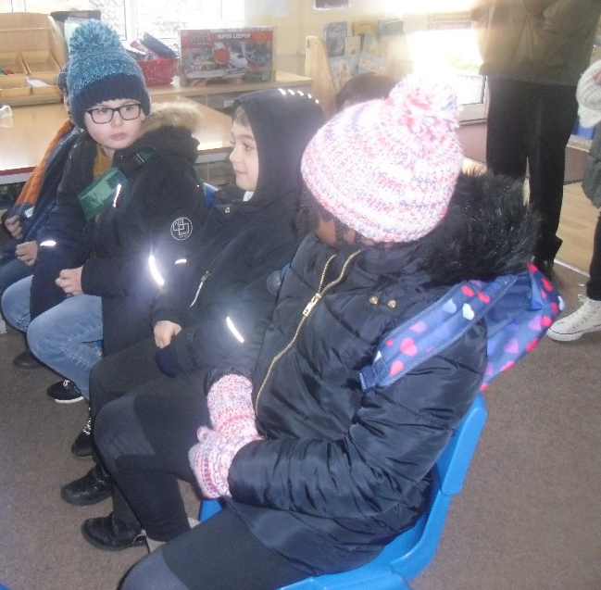

Across the ice field, trying not to make it crack!

We put on our seat belts on the plane
Carefully climbing the icebergs!

